REF: | TASK/ACTIVITY: |  |  |  |  |  |  |  |  |  |  | ASSESSMENT DATE:
DEPT: | LOCATION: |  |  |  |  |  |  |  |  |  |  | ASSESSED BY:
Who may be affected by the task/activity? | Venue Employees |  | Public |  | Contractors |  | Promotors /Production |  | Other (please specify) |  | MANAGERS NAME:
HAZARD | SAFETY RISK |  |  |  | SAFE WORKING PRACTICE/CONTROL MEASURES

Further action required :
Action to be undertaken by : |  | Review Date:
The Residual risk rating must be calculated taking into account control measures already in place.

Severity X Likelihood = Risk Rating
Guidance on risk rating.
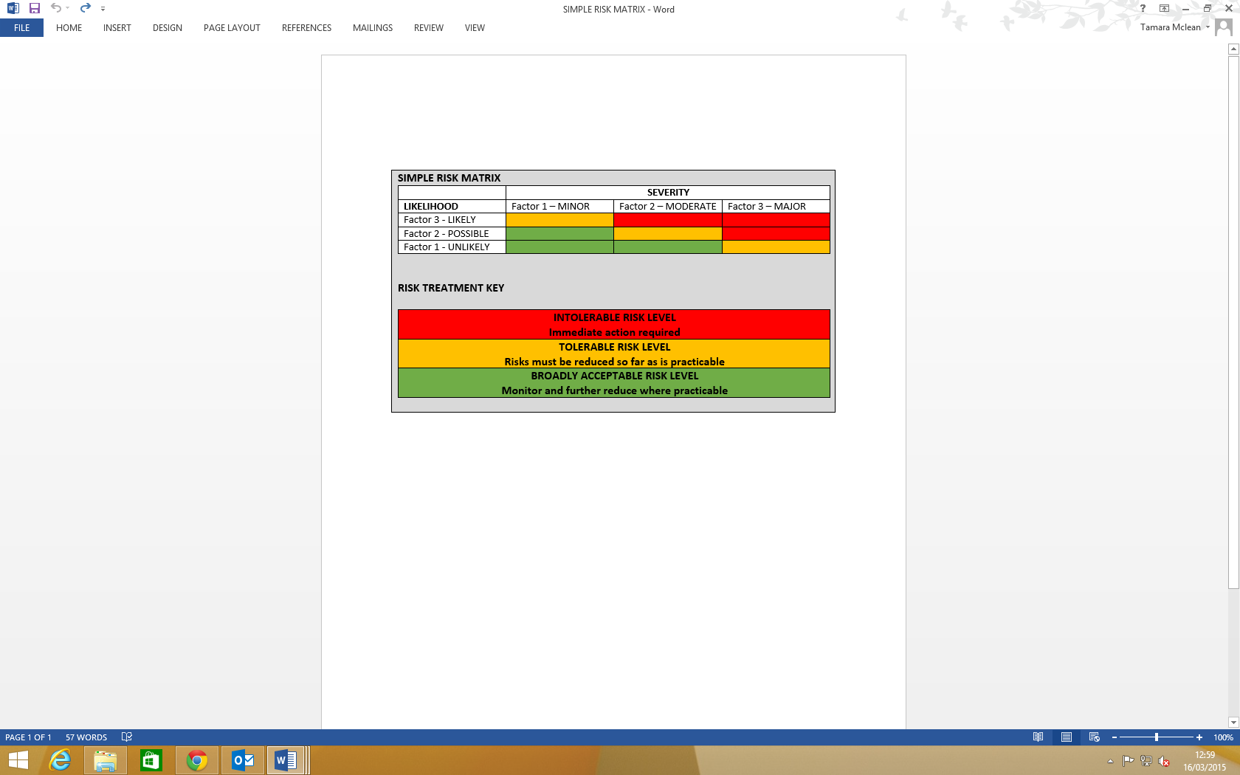
‘Risk Rating’ is a means of ‘measuring’ the risk by multiplying the severity by the likelihood e.g. a severity factor ‘MODERATE’ with a likelihood factor ‘POSSIBLE’ would give a risk rating of 2 x 2 which, of course, gives a ‘score’ of 4.

‘Severity’ is rated as follows:
- FACTOR 3 = death, major injury and occupational diseases as defined by RIDDOR 2013
- FACTOR 2 = ‘over 3 day’ injuries as defined by RIDDOR 2013
- FACTOR 1 = injuries where persons may be off work for less than 7 days, or not at all
‘Likelihood’ is rated as follows:
- FACTOR 3 = could happen anytime
- FACTOR 2 = might happen sometimes
- FACTOR 1 = where harm is unlikely to occur
Risk ratings:
- (HIGH RISK) From 6 - 9 INTOLERABLE RISK LEVEL Immediate action required.
- (MEDIUM RISK) From 3 - 5 TOLERABLE RISK LEVEL Risks must be reduced so far as is practicable.
- (LOW RISK) From 1 - 2 BROADLY ACCEPTABLE RISK LEVEL Monitor and further reduce where practicable
Please note.
Priority should be given to hazards that affect large numbers of people and/or could result in serious injury.
IMPORTANT - This risk assessment should be reviewed every 24 months, or whenever there is a significant change in the task or activity and following any accident or incident involving this task or activity.

