**NIC**

**HEALTH & SAFETY**

**INDUCTION WORKBOOK**

**A picture containing building, sky, outdoor, ground

Description generated with very high confidence**

**Useful numbers;**

**A close up of a logo

Description generated with high confidence**

**Health & Safety Advisor – Tamara Mclean Internal 3210 / 07525 950710**

**General Manager – Donna Gately 0115 8533030 / 07740 094653**

**Head of Operations – Stephen Chaston 0115 8533021 / 07920 115865**

**Control Room – 0115 8533032**

**Nottingham City Council – Corporate Safety Team 0115 8764328**

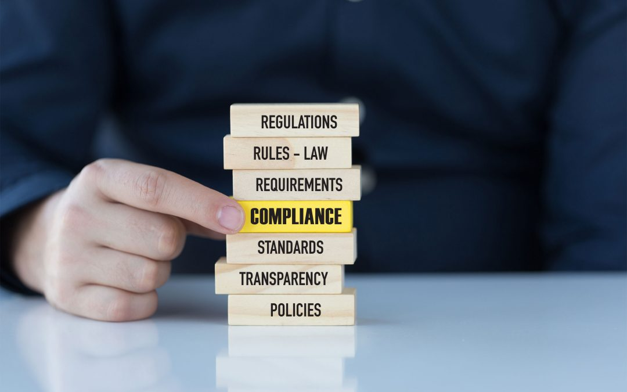

**Health & Safety Overview**

**Health & Safety at Work Act 1974 Provides a legal framework for setting safety standards within an organisation.**

**“It shall be the duty of an employer to ensure, so far as is reasonably practicable, the health, safety and welfare at work of all his employees”**

**As an employee, your duty is to take reasonable care for the health and safety of yourself and others who may be affected by your acts or omissions and to co-operate with your employer to enable them to fulfil their legal duties.**

**Our Health & Safety policy statement describes the overall aims and goals in relation to Health and Safety as a requirement by law.**

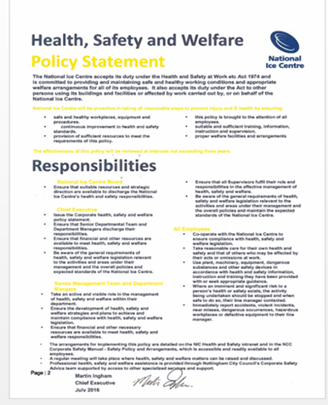

**Four policy statements have been placed around the room, have a look around them and stand by the one you believe to be our correct and most recent H&S Policy Statement.**

**Copies of the statement can be found around the venue, in the Level 3 staff room, the service corridor notice board, Level 5 notice board, Customer Services and on the Health & Safety intranet**

**SPOT THE HAZARDS**

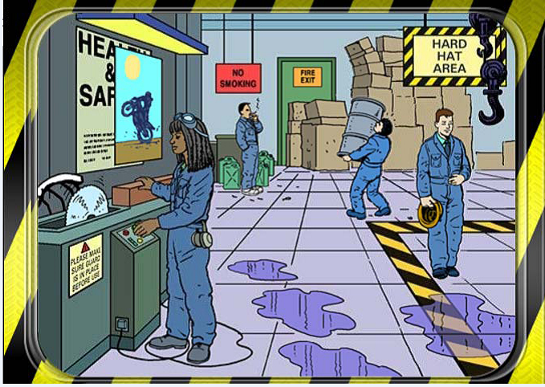

**List As many hazards in the above picture as you can (there are at least 10!)**

**1.**

**2.**

**3.**

**4.**

**5.**

**6.**

**7.**

**8.**

**9.**

**10.**

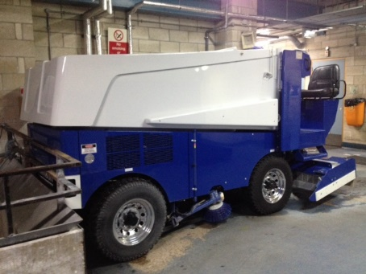

**MOVING VEHICLES**

**Fill in the blanks below, using the words provided.**

Dangers of moving vehicles could be the actual __________ itself, the LOADING or

_____________ of heavy objects and the _______ and ________ that are

either contained or emitted from the vehicle. It is important that we are aware of the key __________

spots around the building.

These are;

Backstage __________ Service yard car park;___________________; Service yard; ____________ areas, service_____________ ; On the_____; flexistore; backstage and the _________ floor.

As staff we need to ensure that customers, especially _____________ are aware of the risks and adhere to house rules. Sometimes we will have limited _______________ to areas during events but not always when _______________________ work is being undertaken. Therefore, it is really important we know what areas pose more _______________ from moving vehicles and ensure that only _______________ drivers use equipment.

**Children maintenance unloading car park access fuel**

**arena risk competent corridor hazard ice**

**Loading fumes Bolero Square Zamboni vehicle**

**Moving vehicles you may encounter;**

A close up of a device

Description generated with high confidence A picture containing truck, road, outdoor, building

Description generated with very high confidence A close up of a device

Description generated with very high confidence A yellow car parked on the side of a road

Description generated with very high confidence

**Motorised Pallet truck Zamboni Ice Resurfacer Forklift Truck Cars**

A close up of a sign

Description generated with very high confidence

**ELECTRICAL SAFETY**

**Fill in the blanks below, using the words provided.**

An electrical fault could cause a _____________ that could then cause damage or injury to another.

_____________ cables could lead to a trip, becoming a _____________ or the cables becoming

_____________. Always switch _____________ electrical appliance s when not in use. The NIC have

qualified _____________ on site who are competent and can deal with electrical issues. A portable

appliance tester (PAT) will test _____________ to make sure it is safe to use.

Always carry out a _____________ check on equipment prior to use. If the equipment is _____________ or

damaged in any way, unplug it and mark it clearly as ‘Faulty – Do not Use’ and advise your line manager or the

buildings department. Do not bring any personal electrical items into the workplace without prior authorisation

from the buildings team.

**Electricians visual damaged equipment**

**Off hazard fire trailing faulty**

What is wrong with these pictures?

A circuit board

Description generated with very high confidence A picture containing bicycle, sitting, indoor, wall

Description generated with high confidence A picture containing indoor, sitting, wall

Description generated with high confidence  

A large ship in the background

Description generated with high confidence

**WORKING AT HEIGHT**

**Fill in the blanks below, using the words provided.**

A lack of _____________ over the task at hand could cause a dangerous situation to occur when working at a

height. Often the pressures of _____________ causes mistakes to be made or a job to take place

unprofessionally. Poor working _____________ can lead to a higher chance of an _____________ taking place.

Risks of _____________ from a height and falling _____________ need to be taken into consideration when

working in these conditions.

Be aware of your _____________ and don’t go into areas you shouldn’t. A high risk area would be the

_____________ floor during an event loading in and out. If contractors come to work at height it is our responsibility to _____________ prior to the commencement of work on site. If you are unsure then seek advice.

It is important to_____________ any concerns. This is so that as a company we can be aware of any

_____________ that may pose a danger to staff or the public. We can then work to _____________ this risk and

ensure we are working in a_____________ environment.

**Arena accident plan objects surroundings**

**Time conditions risks lessen control**

**Report falling safe**

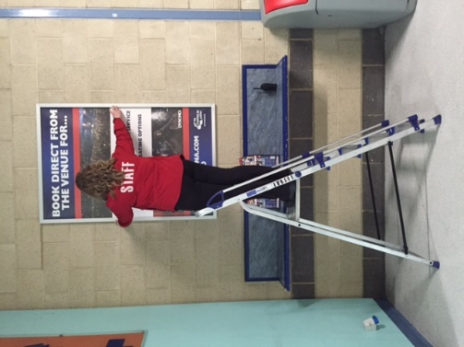 A picture containing indoor, wall, floor

Description generated with very high confidence 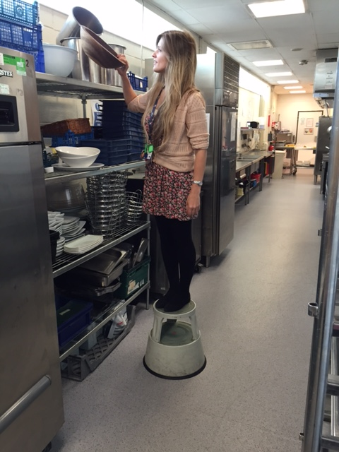

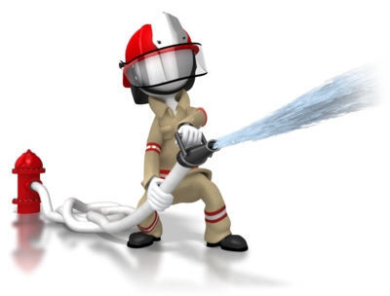

**FIRE**

**Procedures and Evacuation**

**What is the difference between these two?**

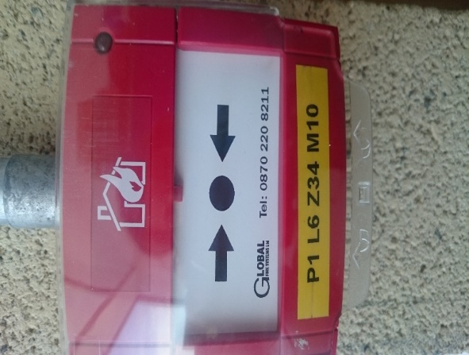 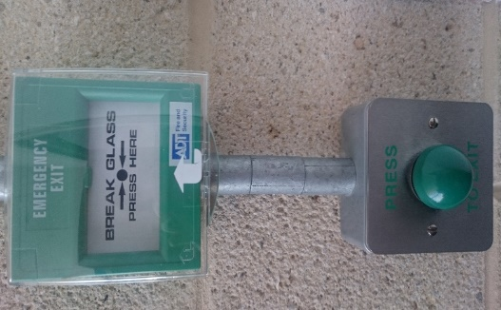

**When one manual call point is activated you will hear the first stage anouncement of the fire alarm. If a second is activated it will automatically send it into the second stage of evacuation. This will be played for you now to hear.**

**Evacuation assembly points;**

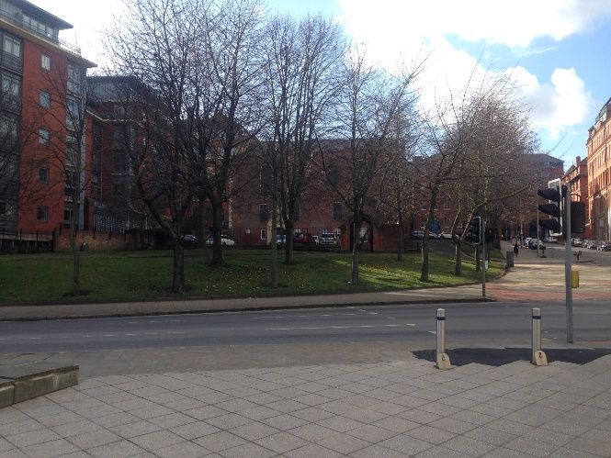 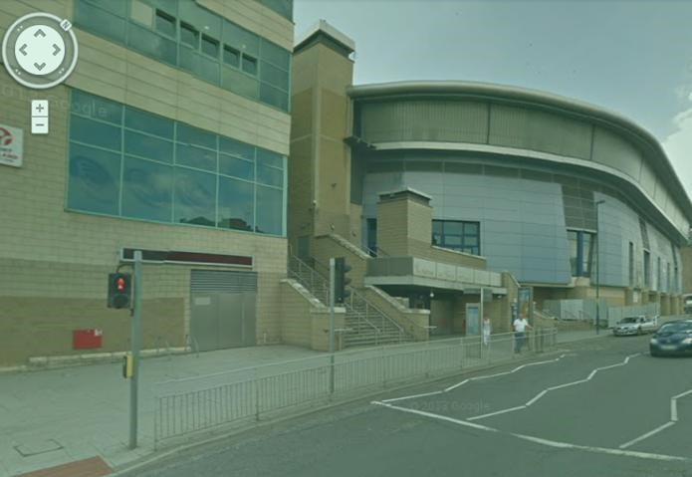

**Bellar Gate /Grassy Knoll Lower Parliament Street**

**7am-11pm – Normal Operating times 11pm-7am – Overnight/Out of hours**



**FIRE**

**Procedures and Evacuation**

**Action to be taken on discovery of a fire**

1. **SOUND the alarm by activating the nearest manual call point**
2. **INFORM the control room by dialling 0115 853 3032 or call on radio**
3. **ATTEMPT to fight the fire with provided extinguishers to aid escape or if confident to do so**
4. **LEAVE the building by the nearest available emergency exit**
5. 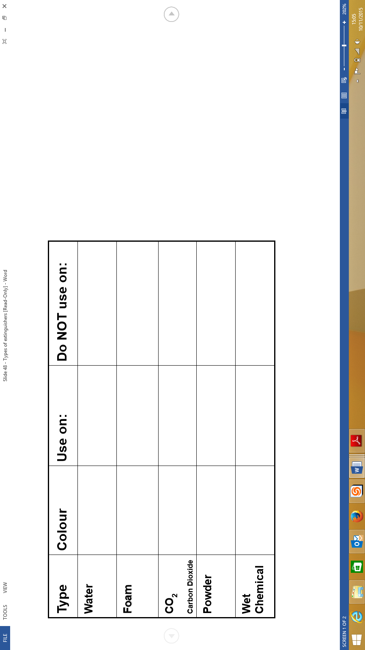**REPORT to the evacuation assembly point.**

**Watch the video Bradford Fire.**

**Watch the fire extinguisher video and complete the following table.**

**PPE**

**Personal**

**Protective**

**Equipment**

A close up of a toy

Description generated with high confidence

**If your role requires the use of PPE, it will be provided to you by your Manager. You will have to sign for this on a Record of Issue**. **It is your responsibility to keep your PPE in good** **clean condition and report any defects or damage to your manager as soon as possible.**

**What types of PPE are there?**

**Select one or more pieces of PPE from the desk in front of you, make sure everyone in your group has something different.**

**Are these acceptable? Don’t let this be you!**

**A picture containing clothing, indoor

Description generated with very high confidence** 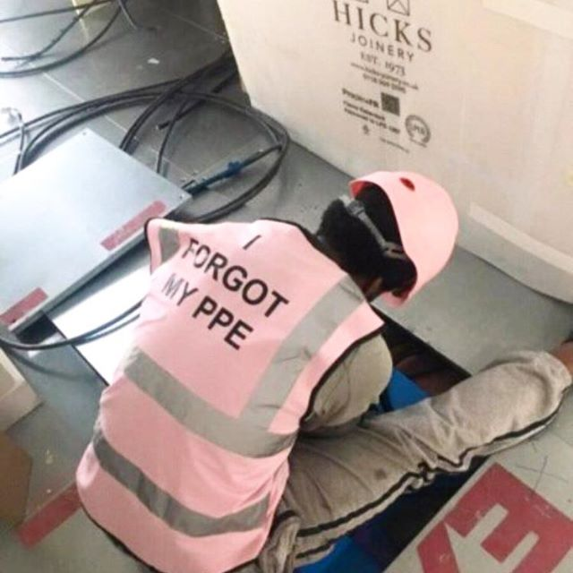

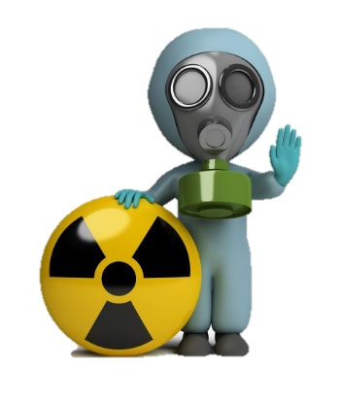

**COSHH**

**COSHH is the law that requires employers to control substances that are hazardous to health.**

**Most businesses use chemical products. These could cause harm to employees, contractors and other people.**

**Sometimes substances are easily recognised as harmful. Common substances such as paint, bleach or dust from natural materials may also be harmful.**

**Please go to the COSHH station to undertake the following tasks;**

1. **Match the COSHH picture symbols with the correct hazard.**
2. **Complete the COSHH table below.**
3. **Match each product to the correct MSDS sheet and Risk Assessment.**
4. **Using the piece of PPE you have already obtained, check the documentation to see which product you can safely use with only the piece of PPE you have. If you require more than one piece of PPE, team up with someone else!**

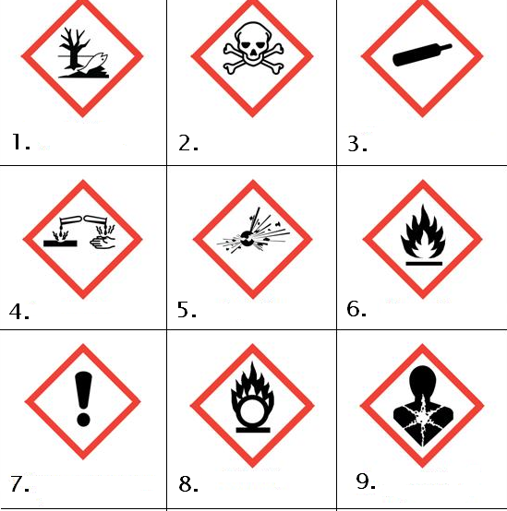



**NOISE AT WORK**

**WHAT EMPLOYEES NEED TO DO:**

**Co-operate - follow work methods**

**Use hearing protection provided – especially in hearing protection zones**

**Report any problems**

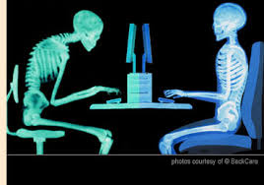

**DISPLAY SCREEN EQUIPMENT**

**What injuries could we get from using a computer?**

* **Work related upper limb disorder (wrists, fingers, thumbs, arms, neck or shoulders)**
* **Headaches**

**How can we prevent this from happening?**

* **Equipment; Chair, Keyboard, Screen**
* **Environment; Lighting, Noise**
* **Risk Assessment**
* **Eyesight tests**

**Take regular breaks 1-2 minutes every 20 minutes of keyboard work.**

**Undertake an online DSE assessment for your workstation set up if using a PC/Laptop on a regular basis.**

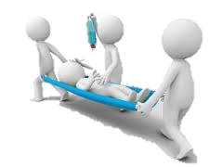

**FIRST AID** 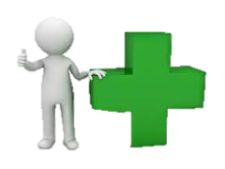

**First aid for customers within the venue is split into 3 provisions.**

**First Aid trained NIC employees – Public Skating Sessions**

**St John staff – Hockey matches, Conferences and small events**

**EMAS (East Midlands Ambulance Service) – Hockey, Conferences, and Events with capacity over 4000**

**ALL accidents and incidents must be recorded whether or not they result in harm or injury. This includes employee, contractor and customer accidents, incidents and near misses as well as work related illnesses.**

**Near misses are an event that took place, that has the potential to cause harm, but didn’t result in any injury or damage. Example: a radio dropped down the glass stairwell, but didn’t strike anyone, could easily have hit persons below causing injury but didn’t.**

**Watch the video and complete the accident form. Accident reports are completed on the online reporting system. If you do not have access to this, complete a paper copy that can then be uploaded to the system.**

**Completed accident forms are then allocated to the appropriate person. This will either be the Department Manager of the injured person if it is an employee, or the Department Manager of the area where the accident occurred. For instance, in the case of a customer, this could be the Manager on Duty (for public skating) the Front of House Manager (for an event) or Event Manager (for production).**

**An investigation will take place to determine the cause of the accident and highlight any learning outcomes, training or procedures which may need to be addressed.**

**Reporting accidents allows us to highlight any trends that may occur throughout the venue or within certain departments or customer profiles.**

**A close up of a sign

Description generated with high confidence**

**INCIDENT REPORTING**

**For adverse events that are not classed as an accident or** **near miss, you must complete an incident form. This could be a theft, violence to employees/customers, damage to property, power outage or plant and machinery issues.**

**The NIC report form is available on the Health & Safety intranet site.**

**The employee who has been involved in the incident/assault must complete the first side of the relevant form, as soon as possible after the incident.**

**A copy of this side of the form should be sent to Linda Davey – Operations Supervisor, Level 3**

**The form should then be passed to the employees Line Manager to complete the reverse of the form with their investigation. A copy of the fully investigates form can be retained by the Department Manager if required.**

**The completed investigation is then passed to the Head of Operations to review the incident and suggest any further investigation or recommendations if they are considered necessary.**

**Watch the video and complete an incident form.** 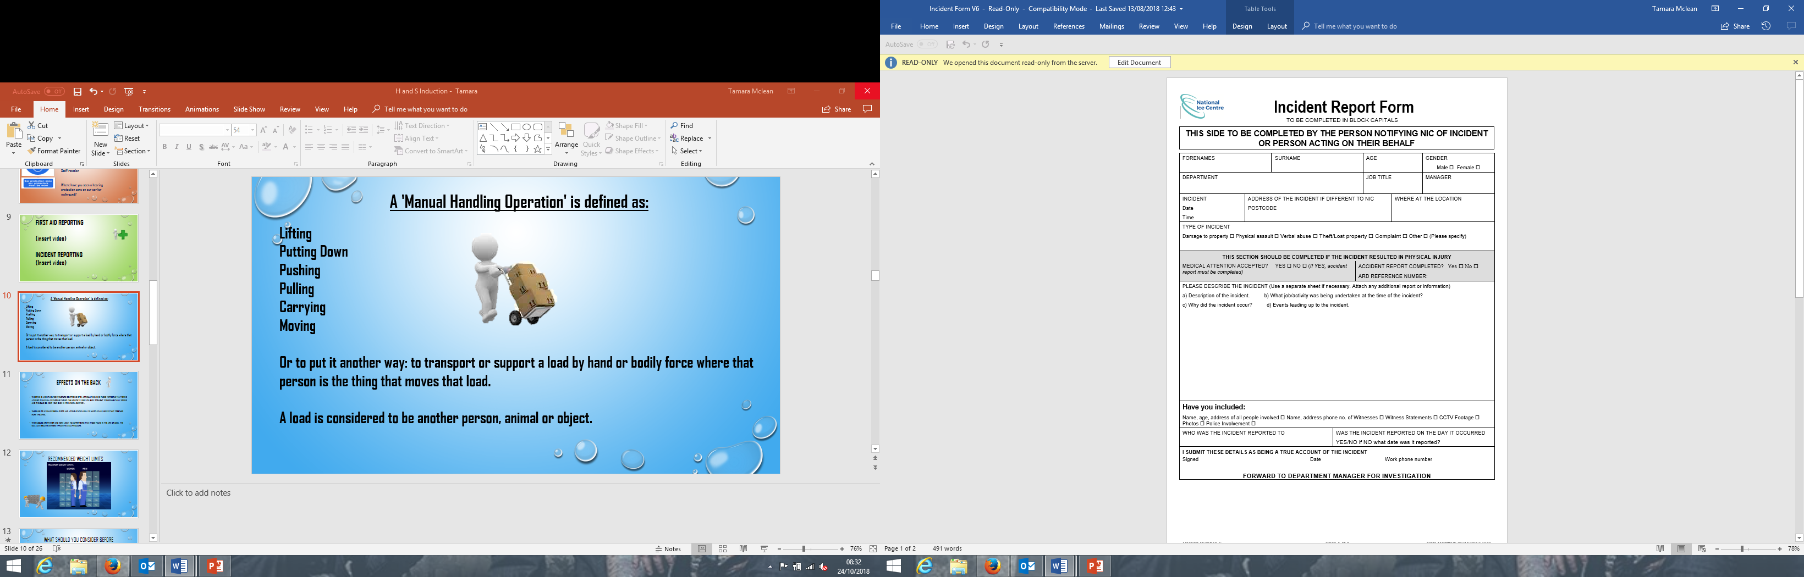

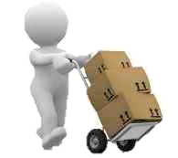

**MANUAL HANDLING**

**Is the term used to describe any lifting, carrying, pushing, pulling or moving of a load using hand or bodily force.**

**When manual handling, consider TILE, assess the task you are undertaking, consider the person/s lifting, what are their capabilities? Consider the load, the weight, size and shape. Consider the environment, the route you are taking, the lighting, any stairs or doors? If required, use lifting aids, such as trolleys or cages, use another person to share the load or to watch the route for you and open doors.**

**If you are unsure, don’t do the task and speak to your Line Manager.**

**T - TASK**

**I - INDIVIDUAL**

**L- LOAD**

**E- ENVIRONMENT**

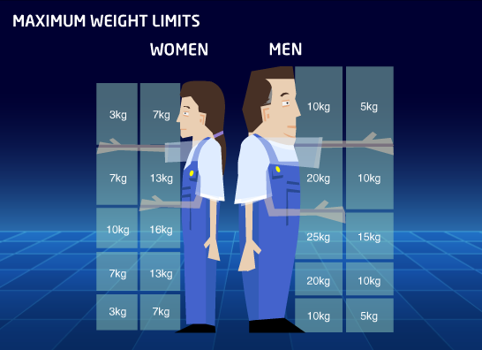

**WATCH THE CHILDS PLAY VIDEO**

**And make your own spine**

**Demonstrate manual handling**

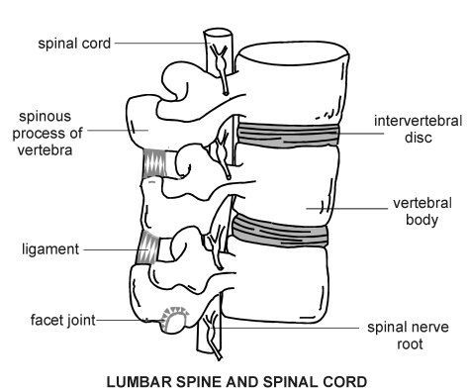 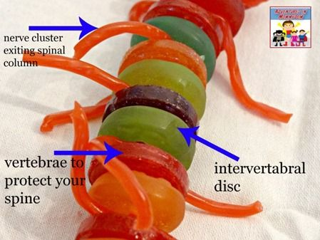

**A close up of a toy

Description generated with high confidence**

**USEFUL INFORMATION**

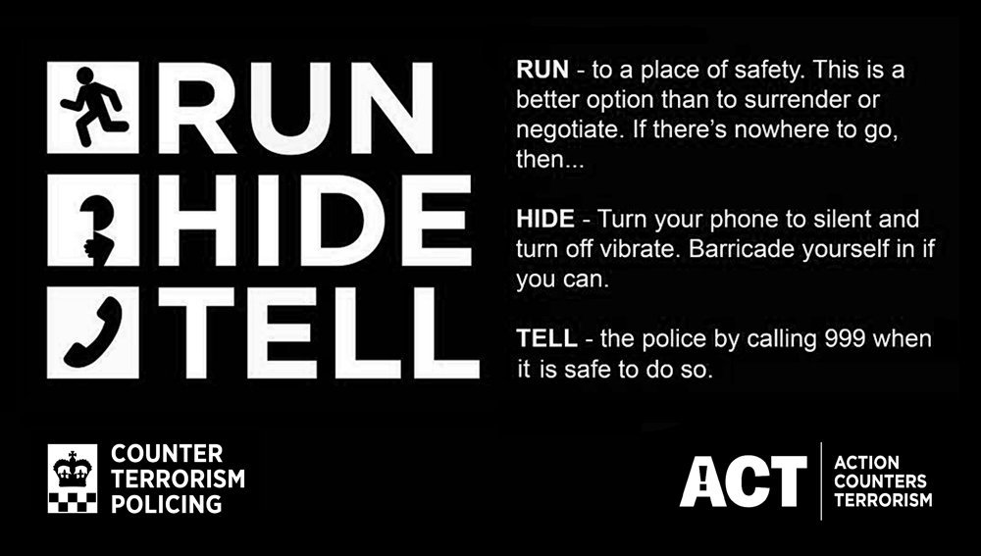

**Counter terrorism policy can be found on the H&S intranet under Emergency & Contingency Plans**

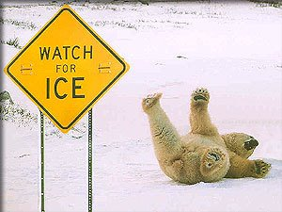

**Slips, trips and falls are the most common cause of major injuries in the workplace and the second highest cause of absence from work over three days.**

**If you see anything that is likely to cause a slip or trip please take action to rectify the problem, report it to your Manager or the Control room immediately.**

**If your job involves Lone Working, you must speak to your manager about the controls in place to ensure your safety. Simple controls may include the use of;**

* **A signing in and out board**
* **A mobile phone or radio**
* **A shared calendar**
* **Manager briefings**

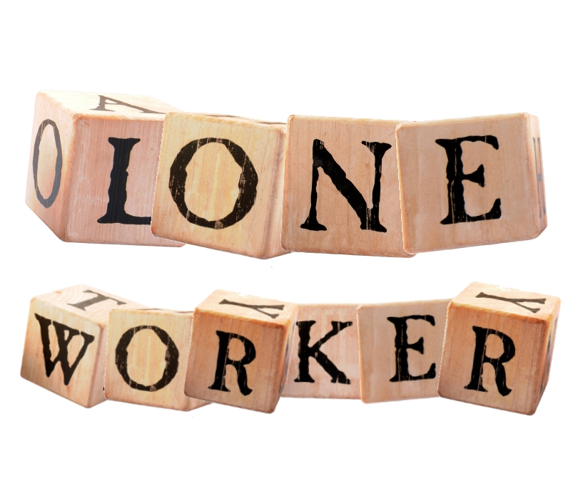



**HEALTH & SAFETY QUIZ**

|  |  |  |
| --- | --- | --- |
| **1** | **WHAT COLOUR IS A MANUAL CALL POINT?** |  |
| **2** | **WHAT FIRE EXTINGUISHER IS IDENTIFIED BY A BLACK STRIP?** |  |
| **3** | **WHERE IS THE NORMAL OPERATING TIMES ASSEMBLY POINT?** |  |
| **4** | **WHAT FORM WOULD YOU USE TO REPORT A THEFT?** |  |
| **5** | **IN MANUAL HANDLING, WHAT DOES T.I.L.E. STAND FOR?** |  |
| **6** | **WHAT DOES THIS SIGN M28BMEAN?** |  |
| **7** | **WHERE CAN YOU FIND THE HEALTH & SAFETY POLICY?** |  |
| **8** | **WHAT FORM WOULD YOU USE TO REPORT A NEAR MISS?** |  |
| **9** | **WHAT ACCIDENTS SHOULD YOU REPORT?** |  |
| **10** | **WHAT DOCUMENTS ARE NEEDED FOR ANY CHEMICALS ON SITE?** |  |

**A picture containing holding

Description generated with high confidence**

**HEALTH & SAFETY SIGN OFF**

**I confirm that I have completed the Health & Safety Induction and understand the information provided to me in this booklet. If I require any further information or guidance, I can speak directly to my Line Manager or to the Health & Safety team.**

**NAME: ____________________________________________________________________**

**SIGNED: ___________________________________________________________________**

**DATE: _____________________________________________________________________**